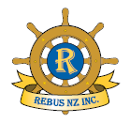
Rebus
(Steering a safe course through our retirement years)

Rebus Clubs are in many parts of New Zealand, some are
men only, some ladies only and others are mixed.

The Rebus Club of XXXXXXX XXXXXXXXXXXXXXX
(formerly affiliated to Probus South Pacific Ltd)
was established in 19xx. We have followed the example of other Clubs in NZ by changing our name to reflect independence from the former governing body in Australia.
Membership is open to all active retired or semi-retired persons
of good character.
No community service obligations, just the pleasure of
meeting up with others of a similar age and interests. Many
new friendships are made within Rebus.
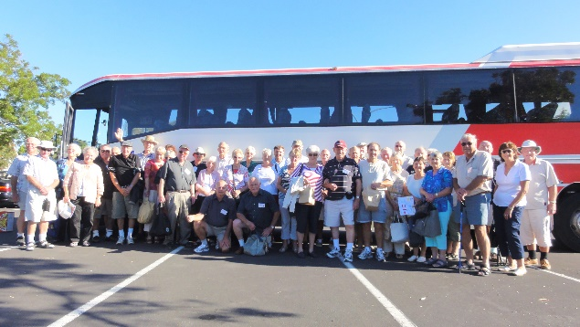
Annual fees $xx plus $xx joining
fee.
We meet x^{st} xxxday morning each Month, 9.45am – noon at St John’s Hall, Smith Street.
Excellent speakers, low - cost trips and various interest groups for both members and partners.

For more information, call:

Kay Jones Phxxxx xxx or Fred Dagg Ph xxxx xxx
Or visit: www.(if you have a website)

